**NETTING TRIAL PROGRESS REPORT WEEK 4 & WEEK 3**

**Progress to date (12th July):**

This week, we have continued to collect logbook data and made a field visit to observe the net at South Shields. Three netting locations have been active – South Shields, Amble and Boulmer.

The trial has comprised 48 separate netting events to the end of today, of various durations. We have collected logbook data from licensees covering 28 of these netting events, and made 15 fisheries observations by boat, totalling over 46 hours of direct boat-based field observations.

From the catch data secured to date (some logbook data remains to be collected) a total of over 1500 sea trout have been captured and 10 salmon. The majority of these salmon were only lightly entangled and all were released alive.

Last Monday, NE Area Director Catherine Saxon and Toby Willison, Executive Director of Operations made a site visit to observe the modified T net at South Shields in operation, and to discuss the trial with Derek Heselton of the NFFO.

To secure better underwater video footage of salmon and sea trout interacting with the net, we have approached Cefas, who have agreed to provide their Remote Operated Vehicle (ROV) – which is basically a tethered mini-submarine with forward and rear facing video cameras.

This promises to provide improved evidence regarding the mode of operation of the nets, and the behavioural responses of fish which encounter them.

**Forward look:**

Next week we will resume boat based fisheries observations using the RIB and continue to shoot underwater video to build our evidence base and better understand fish response to encountering the net. We will also continue to collect logbook data to maintain a current catch record.

We hope to undertake the ROV survey the following week, weather permitting.

**Progress to date (5th July):**

Three locations have been active as part of the trial – South Shields, Amble and Boulmer. There have been 35 netting events, of various durations. We have collected logbook data from licensees covering 23 of these netting events.

 We have made over 40 hours of field observations by Agency RIB and on licensees’ boats, observing 15 individual netting events.

 Last week we shot more underwater video footage and numerous still photographs to help build our evidence base, and made 5 fisheries observations. Over the last 3 weeks we have taken photographs and video footage including:

•        Salmon being entangled in a T net and subsequently being released

•        Sea trout being enmeshed and retained

•        The nets being checked and operated by licensees

•        Seals interacting with the nets and trying to take fish from them

•        Aerial footage from an Agency drone of the modified T net fishing at South Shields that shows the size, configuration, scale and location of a net in operation (still attached)

We are working to secure the use an underwater drone, which has video capabilities, piloted by colleagues from Cefas to gather footage as evidence of the response of fish encountering the T net, and their subsequent capture or escape in coming weeks.

We have yet to analyse the catch records from last week in detail, but a check of logbooks shows catches are increasing, with total sea trout landings now over 300 and with only a very small number of salmon captured, the majority of which were lightly enmeshed and released with little obvious harm.

To date, only 2 salmon have been recorded where they have been significantly entangled in the net, resulting in physical damage.

**NEW NET DESIGN**

Further details on the design of the modified T net are set out below.  Feel free to share with anyone with an interest.

The traditional Northumbrian T net looks as drawn below:

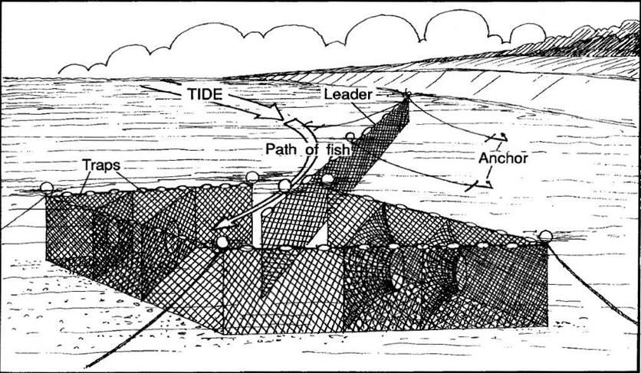

The new net type is a modification of the traditional Northumbrian T net, and is very similar in design:

|  |
| --- |
|  |
|  | cid:image007.png@01D53741.58706320 |

A drone photo taken last week at South Shields shows the modified net in-situ – the shape can be picked out from the orange floats on the head rope:

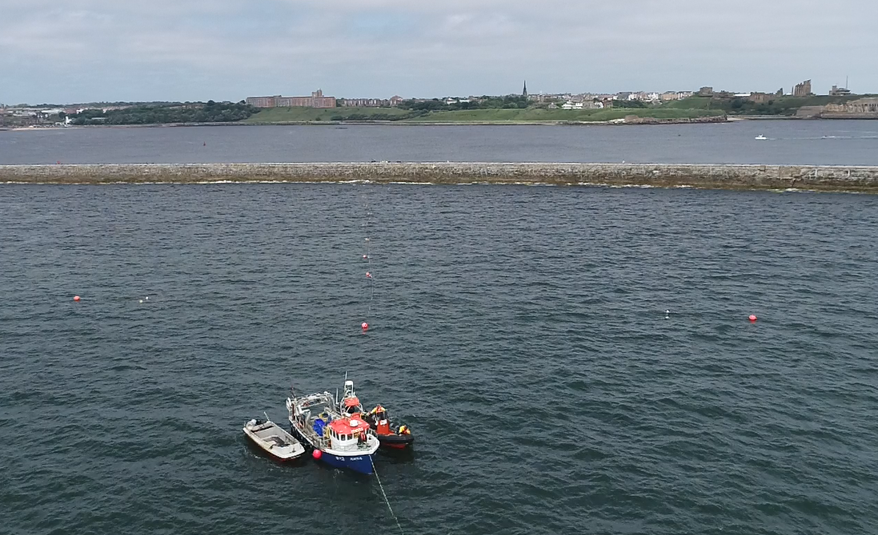

The traditional T and modified T net share many specifications. They are:

Comprised of plain unarmoured sheets of nylon netting (6Z, 8Z or similar) and consist of a headpiece not exceeding 92 meters in length and a tail piece or leader not exceeding 230 meters in length.

Shot from a boat manned by not more than three persons or laid along the ground at low water in the form of a letter ‘T’.

Comprised of netting with a mesh size of not greater than 2 inches measured knot to knot, or 8 inches measured on all four sides.

Maintained stationary by anchors or weights and be suspended in the water by means of floats, with the open court of the headpiece leading on each side to two arms comprising the terminal T.

In each side of the headpiece, one or two sheets of netting set at right angles to the side netting, creating one or two boxes or monks, each with a free gap measuring not less than 24 inches wide on the upper side, not less than 30 inches deep, and not less than 18 inches wide on the lower side, located in the upper part of the net to allow fish passage.

The main difference is that in the modified net, the side netting in the last box forming the end of the headpiece of the T has been removed, allowing fish which pass into this last box through the inscales to escape the net. .  The design seems to be working and very few salmon have been entangled to date.

The released salmon have generally been very lightly snagged by the jaw or fins. They are physically too large to become wedged in the 2” mesh of the T net.